**PLANNING PROPOSAL GOSFORD CITY COUNCIL IN RESPECT OF LOT C DP 433631, LOT X DP 366932, LOT 2 DP 349187, LOT C DP 347823, LOT B DP 347709, LOT 8B DP 412722 & LOT 3 DP 829025 PAINTERS LANE TERRIGAL**

This Planning Proposal has been drafted in accordance with Section 55 of the *Environmental Planning and Assessment Act, 1979* and the Department of Planning & Environment's *A Guide to Preparing Planning Proposals* and *Guide to Preparing Local Environmental Plans.*

A gateway determination under Section 56 of the Environmental Planning and Assessment Act is requested from the DP&E.

**Part 1 Objectives or Intended Outcomes**

***Section 55(2)(a) A statement of the objectives or intended outcomes of the proposed instrument.***

The objective/intended outcome of the Planning Proposal is to permit dual occupancy, multi dwelling housing and residential flat buildings development along the Painters Lane frontage of the “Rapedo Lands” site.

**Part 2 Explanation of Provisions**

***Section 55(2)(b) An explanation of the provisions that are to be included in the proposed instrument.***

The objectives/intended outcomes are to be achieved by amending Schedule 1 Additional Permitted Uses as follows:

**Use of certain land in Painters Lane, Terrigal**

1. This clause applies to land at Painters Lane, Terrigal, being Lot C DP 433631, Lot X DP 366932, Lot 2 DP 349187, Lot C DP 347823, Lot B DP 347709, Lot 8B DP 412722 & Lot 3 DP 829025, identified as “Rapedo Painters Lane Land” on the Additional Permitted Uses Map.
2. Development for the purposes of dual occupancy, multi dwelling housing and residential flat buildings is permitted with consent.

and amending the Additional Permitted Uses Map APU_17B under Gosford LEP 2014 to include Lot C DP 433631, Lot X DP 366932, Lot 2 DP 349187, Lot C DP 347823, Lot B DP 347709, Lot 8B DP 412722 & Lot 3 DP 829025.

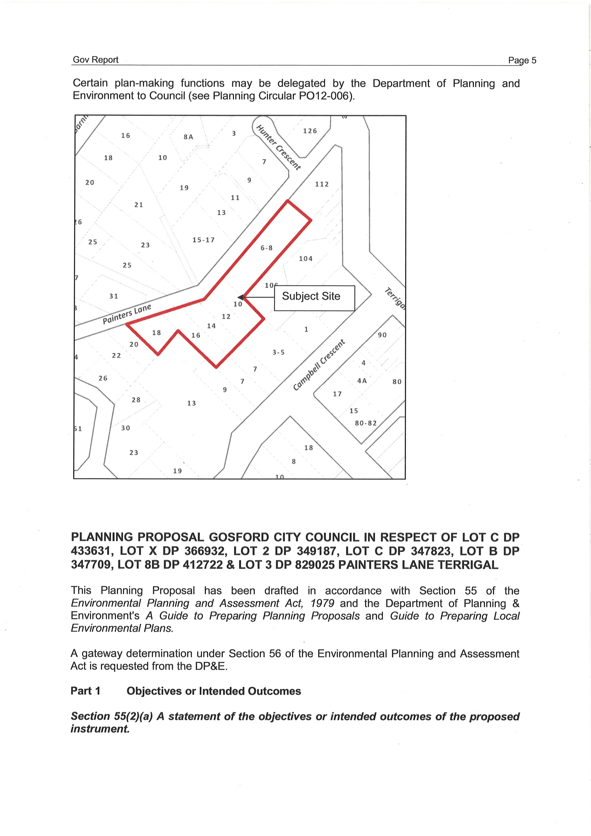

***Section 55(2)(d) If maps are to be adopted by the proposed instrument, such as maps for proposed land use zones, heritage areas, flood prone land – a version of the maps containing sufficient detail to indicate the substantive effect of the proposed instrument.***

Attachment B to this report contains all relevant mapping to the Planning Proposal.

**Part 3 Justification for objectives & outcomes**

***Section 55(2)(c) The justification for those objectives, outcomes and provisions and the process for their implementation (including whether the proposed instrument will comply with relevant directions under section 117).***

**Section A Need for the Planning Proposal**

**1 Is the Planning Proposal a result of any strategic study or report?**

The planning proposal is not the result of a strategic study or report.

**2 Is the Planning Proposal the best means of achieving the objectives or intended outcomes, or is there a better way?**

The Planning Proposal is the best means of achieving the objectives/intended outcomes as it provides an appropriate mechanism for reinstating the range of uses intended for the land.

**Section B Relationship to strategic planning framework**

**3 Is the Planning Proposal consistent with the objectives and actions contained within the applicable regional or sub-regional strategy (including the Sydney Metropolitan Strategy and exhibited draft strategies)?**

Regional strategies include outcomes and specific actions for a range of different matters relevant to the region. In all cases the strategies include specific housing and employment targets also. The Central Coast Regional Strategy 2006 – 2031 is applicable to the subject land and the proposed rezoning. The Planning Proposal will / assist Council in meeting the targets set by the State Government in the Regional Strategy for provision of housing. This Planning Proposal to include “dual occupancy, multi dwelling housing and residential flat buildings” as uses permitted on the site is consistent with the following objectives/actions contained within the Regional Strategy for the reasons specified:

* Concentrates growth and activities in centres.
* Provide increased housing in proximity to the Terrigal Village Centre thereby reinforcing and strengthening the centre and assisting in revitalisation.
* Result in productive use of existing infrastructure.
* Provide opportunity for increased sustainable transport options such as public transport, walking and cycling, leading to healthier communities and enabling people to carry out a number of activities in one location.

**3a** **Does the proposal have strategic merit and is it consistent with the Regional Strategy and Metropolitan Plan, or can it otherwise demonstrate strategic merit in light of Section 117 Directions?**

Yes the Planning Proposal as advocated is considered to have strategic merit it is generally consistent with the Central Coast Regional Strategy and relevant Section 117 Directions see response to section 6 below.

**3b Does the proposal have site-specific merit and is it compatible with the surrounding land uses, having regard to the following: the natural environment (including known significant environmental values, resources or hazards) and the existing uses, approved uses, and likely future uses of land in the vicinity of the proposal and the services and infrastructure that are or will be available to meet the demands arising from the proposal and any proposed financial arrangements for infrastructure provision.**

The proposal is considered to have site specific merit as subject sites are located along Painters Lane which is a narrow residential lane. The sites are essentially the only sites zoned B2 within the Terrigal Centre to have a frontage to what is predominantly a residential lane. Retail/commercial uses at ground level along Painters Lane have the potential to create traffic, urban design and amenity issues for residents along Painters Lane. Development of this frontage for residential purposes has site specific merit as it will result in improved outcomes along Painters Lane which are consistent with the Terrigal Bowl Strategic Plan. Whilst still allowing the site to be developed in conjunction with the retail/commercial frontage of Campbell Crescent.

**4 Is the Planning Proposal consistent with the local Council’s Community Strategic Plan, or other local strategic plan?**

The Planning Proposal is consistent with the Community Strategic Plan – Continuing or Journey which incorporates a number of strategies applicable to the subject planning proposal.

A3.4 Increase the availability of appropriate housing.

A4 Our built environment is a desirable place to be.

B6.3 Plan for population growth within existing developed footprint.

The Planning Proposal is consistent with these strategies because the proposal will result in increased housing along Painters Lane within the area defined as Terrigal Village Centre. It will eliminate the requirement for retail/commercial development along Painters Lane and permit development that is more in keeping with the residential nature of the lane, resulting in reduce amenity impacts for residents of Painters Lane.

**Draft Gosford Centres Strategy**

Attachment One: Centres Inventory and Zoning Recommendations for DLEP of the Draft Gosford Centres Strategy supported the rezoning of Lot 3 DP 829025 Painters Lane to B2 Local Centre for consistency with adjoining lots along Painters Lane. The Planning Proposal is considered to be consistent with the recommendations of the draft Centres Strategy as it is not proposing to alter the B2 zoning of the lots along Painters Lane but add permissible residential uses which are more in character with the residential nature of the narrow Painters Lane.

**5 Is the Planning Proposal consistent with applicable State Environmental Planning Policies?**

The following assessment is provided of the relationship of the planning proposal to relevant State Environmental Planning Policies.

1. **SEPP 55 – Remediation of Land**

Clause 6 of this instrument requires contamination and remediation to be considered in a proposal. In this case, the issues raised in Clause 6 of SEPP 55 do not arise as the subject land has not previously been used for a purpose referred to in "Table 1 Some Activities that may Cause Contamination".

1. **SEPP 71 – Coastal Protection**

Clause 8 of State Environmental Planning Policy 71 identifies “matters for consideration” with the most relevant being the relationship of this site to the surrounding area and any negative impacts in relation to the coastal foreshore; views, overshadowing and access to, from and along the foreshore, the suitability of development given its type, location and design and relationship with the surrounding area.

The planning proposal is seen to satisfy and be consistent with the relevant matters for consideration under this instrument. It will permit residential development at ground level which is more appropriate to the residential character of Painters Lane than retail/commercial development currently required by the B2 zone. Detailed matters of design, overshadowing etc are able to be dealt with at the development consent stage.

**(iii) Other SEPPs:** No other SEPP has application to this planning proposal, although any future development application on the land will be required to consider any relevant SEPPs.

**6 Is the Planning Proposal consistent with applicable Ministerial Directions (Section 117 directions)?**

The following assessment is provided of the consistency of the Planning Proposal with relevant Section 117 Directions applying to Planning Proposals lodged after 1 September 2009. Section 117 Directions are only discussed where applicable. The Planning Proposal is consistent, with all other Section 117s Directions or they are not applicable

1. **Direction 1.1 Business and Industrial Zones**

The direction applies when a relevant planning authority prepares a planning proposal that will affect land within an existing or proposed business or industrial zone. The objectives of the Direction are to :-

* 1. encourage employment growth in suitable locations;
  2. protect employment land in business and industrial zones; and
  3. support the viability of identified strategic centres.

The proposal will meet the objectives, as allowing Painters Lane to be developed for residential development will support the viability of the Terrigal Village Centre whilst minimising the amenity impacts on Painters Lane Residents.

1. **Direction 2.2 Coastal Protection**

The subject site is located within the Coastal Zone. It must therefore include provisions that give effect to and are consistent with:-

1. The NSW Coastal Policy: A Sustainable Future for the New South Wales Coast 1997,
2. The Coastal Design Guidelines 2003, and
3. The manual relating to the management of the coastline for the purposes of section 733 of the *Local Government Act 1993* (the NSW Coastline Management Manual 1990)

The NSW Coastal Policy sets out the following goals relevant to the Planning Proposal:-

1. Protecting, rehabilitating and improving the natural environment of the coastal zone; and
2. Providing for ecologically sustainable development and use of resources.

The proposal will result in a more efficient use of the property and is consistent with the Council’s adopted directions for the Terrigal Centre in the DLEP. It does not prevent or inhibit the protection, rehabilitation and improvement of the natural environment of the coastal zone as the subject site is located within a well established residential/commercial precinct.

The Coastal Design Guidelines relate to the design and location of new settlements and the design of development in the coastal zone. The subject site is located in an existing village centre, however the design of any future development on the site will need to have consideration to these guidelines. It should be noted that the Coastal Design Guidelines recommend heights of generally up to 4 storeys for Coastal Towns and three storeys for coastal villages. The guidelines also state that:

“*Heights are subject to place-specific urban design studies. New development is appropriate to the predominant form and scale of surrounding development (either present or future), surrounding landforms and the visual setting of the settlement. Buildings avoid overshadowing of public open spaces, the foreshore and beaches in town centres before 3pm midwinter and 6.30pm Summer Daylight Saving Time. Elsewhere avoid overshadowing of public open spaces, the foreshores and beaches before 4pm midwinter and 7pm Summer Daylight Saving Time.”*

The heights for the subject site are not the subject of a place specific urban design study nor do they comply with the generally recommended heights for centres on this scale In this regard the planning proposal is inconsistent with this direction. However they are the heights contained within the current GLEP 2014 the Applicant does not propose that the heights applicable to the site be amended as part of this Planning Proposal.

The NSW Coastline Management Manual has no direct application due to the fact that the site does not fall within the inter tidal area where coastal processes are most prevalent.

**(iii) Direction 2.3 – Heritage Conservation**

(i) This direction applies when a relevant planning authority prepares a planning proposal. A planning proposal must contain provisions that facilitate the conservation of:-

(ii) Items, places, buildings, works, relics, moveable objects or precincts of environmental heritage significance to an area, in relation to the historical, scientific, cultural, social, archaeological, architectural, natural or aesthetic value of the item, area, object or place, identified in a study of the environmental heritage of the area;

(iii) Aboriginal objects or Aboriginal places that are protected under the *National Parks and Wildlife Act 1974*, and

(iv) Aboriginal areas, Aboriginal objects, Aboriginal places or landscapes identified by an Aboriginal heritage survey prepared by or on behalf of an Aboriginal Land Council, Aboriginal body or public authority and provided to the relevant planning authority, which identifies the area, object, place or landscape as being of heritage significance to Aboriginal culture and people.

Having regard to the cleared and disturbed nature of the site due to its long term usage for residential purposes, it is unlikely that there are any remaining aboriginal relics if they existed in the first place. Council records do not indicate the presence of Aboriginal relics on the land.

**(iv) Direction 3.1 Residential Zones**

This direction applies to all relevant planning authorities and to when that relevant planning authority prepares a planning proposal that will affect land within:-

1. an existing proposed residential zone (including the alteration of any existing residential zone boundary);
2. any other zone in which significant residential development is permitted or proposed to be permitted.

The objectives of this zone are to:

1. to encourage a variety and choice of housing types to provide for existing and future housing needs;
2. to make efficient use of existing infrastructure and services and ensure that new housing has appropriate access to infrastructure and services; and
3. to minimise the impact of residential development on the environment and resource lands.

The Planning Proposal is considered to be consistent with this Direction as it intends to allow additional residential uses to be permitted on the subject site thus providing a variety and choice of housing types and capitalises on the existing infrastructure of the Terrigal village centre.

1. **Direction 3.4 Integrating Land Use and Transport**

Clause 4 of the Direction requires a planning proposal to locate zones for urban purposes and include provisions that give effect to and are consistent with the aims, objectives and principles of *Improving Transport Choice – Guidelines for Planning and Development 2001 and The Right Place for Business and Services – Planning Policy 2001.*

The proposal is consistent with this direction as it locates residential uses adjacent to an existing centre which is located on a major bus route. If the site is developed in conjunction with the remainder of the Rapedo site it will improve the services available to the residents of Terrigal and has the opportunity to reduce car dependence and distances travelled by car for both residents and tourists.

**(vi)** **Direction 5.1 Implementation of Regional Strategies:** Clause (4) of the Direction requires Planning Proposals to be consistent with a Regional Strategy released by the Minister for Planning.

The Planning Proposal is considered to be consistent with the objectives and actions contained in the Central Coast Regional Strategy 2006 – 2031 as indicated in the response to 3 and 4 above.

**(vii) Direction 6.1 – Approval and Referral Requirements:** Clause (4) of the Direction requires a Planning Proposal to minimise the inclusion of concurrence/consultation provisions and not identify development as designated development.

This Planning Proposal is consistent with this direction as no such inclusions, or designation is proposed.

**(viii) Direction 6.3 – Site Specific Provisions:** The objective of this direction is to discourage unnecessarily restrictive site specific planning controls and applies when a relevant planning authority prepares a planning proposal that will allow a particular development to be carried out.

The Direction states that a planning proposal that will amend another environmental planning instrument in order to allow a particular development proposal to be carried out must either:

1. allow that land use to be carried out in the zone the land is situated on, or
2. rezone the site to an existing zone already applying in the environmental planning instrument that allows that land use without imposing development standards or requirements in addition to those already contained in that zone, or
3. allow that land use on the relevant land without imposing any development standards or requirements in addition to those already contained in the principal environmental planning instrument being amended.

Although the “Rapedo Lands” are the subject of heights and FSR’s that are site specific and not consistent with those controls for other B2 zoned land within the Terrigal Village Centre. Height and floor space controls within the Terrigal village centre were the result of the Terrigal Bowl Strategic Plan study. The Applicant does not propose to amend the controls which currently apply to the site which were the result of a site specific LEP which was supported by Council and DoPE and ultimately gazetted as LEP 432. The controls were then carried over into GLEP 2014 which was supported by Council and DoPE and gazetted on 11 February 2014. The Planning Proposal therefore considered to be consistent with this Direction as the applicant is requesting a height and FSR consistent with the current GLEP 2014.

**Section C Environmental, social and economic impact**

**7 Is there any likelihood that critical habitat or threatened species, populations or ecological communities, or their habitats, will be adversely affected as a result of the proposal?**

The land has been developed for urban purposes for a number of years and has been cleared for development purposes. Council’s vegetation mapping does not indicate any vegetation on the site. An inspection of the site confirmed that the vegetation is consistent with Bells mapping adopted by Council.

**8 Are there any other likely environmental effects as a result of the Planning Proposal and how are they proposed to be managed?**

The inclusion of the site in Schedule 1 of the Gosford LEP 2014 with the additional permitted uses of “dual occupancy, multi dwelling housing and residential flat buildings” will not result in any other significant environmental effects.

**9 How has the Planning Proposal adequately addressed any social and economic effects?**

The planning proposal will allow the subject site to be developed for residential purposes at street level as well as any upper level. This is consistent with directions outlined in the Terrigal Bowl Strategic Plan which was prepared with considerable community involvement. Development of the Painters Lane frontage for residential purposes will result in improved urban design and amenity outcomes for Painters Lane residents. Residential development at street level as well as upper levels along the Painters Lane frontage is more in character with the residential nature of the remainder of Painters Lane than if the site was developed for commercial/retail purposes at street level.

**Section D State and Commonwealth interests**

**10 Is there adequate public infrastructure for the Planning Proposal?**

Conventional urban services are available to the land.

Council’s Sustainable Corporate & City Planning Transport Planner noted with regard to the Planning Proposal for Lot 3 Painters Lane which proposed commercial/retail uses on the site, that the lane has limited traffic capacity (12 wide) and has westerly increasing grades with limited vertical sight lines combined with poor pedestrian facilities. There is also limited traffic visibility (horizontal sight lines) at the intersection of Painters Lane and Terrigal Esplanade.

Council’s Transport Planner advises he has no objections to the Planning Proposal subject to the following:

* The abovementioned capacity limitations of Painters Lane should be considered and addressed in the design of any future development on the site.
* Future development on the proposed site should be consistent with recommendations of current traffic/parking studies and Development Control Plans applicable for the area.
* Preferable vehicle access to Campbell Cres is not required to safeguard the optimum pedestrian safety and amenity levels.

Detailed traffic considerations could be undertaken at the DA stage.

The Planning Proposal was referred to Council’s Water & Sewer New Development Officer who advised the proposal will not impact on previous agreements and comments regarding water supply and sewerage. Comments relating to the previous Planning Proposal are as follows.

Water and Sewer are available at the site and the Water and Sewer Directorate have no objection to the proposal subject to the following:

1. The applicant shall be responsible for undertaking a water supply and sewer systems capacity analysis on the water and sewer reticulation mains servicing the proposed development. The analysis shall extend to a point within the reticulated water supply and sewerage systems where proposed demands / loadings from the rezoned area represent 5% or less than the total capacity of each system. The analysis shall assess the impact the proposed rezoning / development has on Council's existing water and sewerage reticulation systems. The capacity analysis shall be in accordance with WSAA Method for determining system capacity and shall be based upon full development of the area serviced by the water and sewer systems utilising the current land zonings without the rezoned area and a second analysis with the inclusion of additional demands / loads created by the proposed rezoning and subsequent development. Analysis, augmentation and costs would need to meet with W&S Asset Management approval.
2. Prior to development consent being granted on the land the developer shall be responsible for the design and full cost of any specific augmentation works identified by the systems analysis as being necessary due to the proposed rezoning / development. All works identified shall be constructed by and at the full cost of the developer prior to transferring to Council for care and control.
3. Prior to development consent being granted the applicant shall submit for consideration and approval by the W&S Asset Management Development Group a Plan of Management for Water Supply incorporating water saving initiatives.

A section 307 certificate under the Water Management Act 2000 will be required prior to development of the land.

**11 What are the views of State and Commonwealth Public Authorities consulted in accordance with the gateway determination, and have they resulted in any variations to the Planning Proposal?**

No consultations have yet been undertaken with State and Commonwealth agencies as the gateway determination has not yet been issued.

**Part 4 Mapping**

***S55(2)(d) If maps are to be adopted by the proposed instrument, such as maps for proposed land use zones, heritage areas, flood prone land - a version of the maps containing sufficient detail to indicate the substantive effect of the proposed instrument.***

Attachment B to this report contains all relevant mapping to the Planning Proposal.

**Part 5 Community Consultation**

***Section 55(2)(e) Details of the community consultation that is to be undertaken before consideration is given to the making of the proposed instrument.***

Subject to Gateway support community consultation will involve an exhibition period of 28 days. The community will be notified of the commencement of the exhibition period via a notice in the local newspaper and on the web-site of Gosford City Council. A letter will also be sent to the adjoining landowners (see map below) and the Terrigal Area Residents Association (TARA).